***INVENTORY MANAGEMANT SYSTEM***

**REPORT BY:-**

**RAMA SURYA,SADDESH REDDY,CHANDHU**

section*-*K19QK-G-1

*Roll Numbers:*

**31,27,30**



**Department of Intelligent Systems,**

**School of Computer Science Engineering,**

**Lovely Professional University, Jalandhar**

**November, 2020**

**Student Declaration:-**

This is to declare that this report has been written by us. No part of the report is copied from other sources. All information included from other sources has been duly acknowledged. We aver that if any part of the report is found to be copied, we are shall take full responsibility for it**.**

**SIGNATURE:**

** **



**Name:**

RAMA SURYA

SADDESH REDDY

CHANDHU

**Roll Number:**

RK19QKA31

RK19QKA27

RK19QKA30

**TABLE OF CONTENTS**

TITLE PAGENO.

1.Background and objective of project assigned

1.1 INTRODUCTION

1.2 OBJECTIVE

1.3 DESCRIPTION

1.4 SPOT ANALSYS

2. SOURCE CODE

2.1 BACKGROUND

2.2 PURPOSE

2.3 MANUFACTURING USES

2.4 MOTIVATION

2.5 REFERENCES

**BONAFIDE CERTIFICATE:**

Certified that this project report “INVENTORY MANAGEMENT SYSTEM” is the bonafidework of “MR.Rama Surya, Mr. Saddesh Reddy and Mr.Chandhu” who carried out the project work under my supervision.

<<signature of the supervisor>>

(Due to Covid 19,(

signature is exempted )

Dr. Dhanpratap Singh

UMS ID: 25706

School Of Computer Science

and Engineering

Background and Objectives:

**Chapter 1: INTRODUCTION**

* 1-We developed this project to do the complicated work into an easy way for an shop owner.
* 2- In present system all purchases and the delivery work done manually and it takes very hard work to maintain the information.
* 3-It only makes the process more difficult and hard.
* 4-This aim of the project is to automate the work performed in the shop management system like generating daily purchases, records of items that are available in that shop , record of addresses, rental charges for every delivery, store record of the customer.
* 5-Based on this information you can take decision regarding your business development.

**OBJECTIVE:**

The objective of inventory management is to provide information. Inventory control systems can consist of simple spreadsheets for small start-ups to elaborate, detailed computer database programs for gigantic companies. These inventory control systems track millions of units from the time they're originally purchased until they leave in the hands of a customer.

**DESCRIPTION:**

An inventory management system project that allows user to manage and maintain his/her inventory with ease. The inventory management system has been developed to allow users to add an inventory, delete an inventory, enter inventory quantity and other details, update inventory status and more. The inventory management system has its own intelligently managed support system that allows user to view and manage various inventories added in the system.

**The system provides following features:**

* User may add/update/delete inventory.
* User may add/update inventory details.
* Details include cost, quantity and description.
* Includes forms for inventory inwards and outwards.
* User may create sub inventories.
* An interactive user interface.
* A flexible inventory management system

**SPOT ANALSYS(Screenshots of working of the project):-**

Step – 1 Login

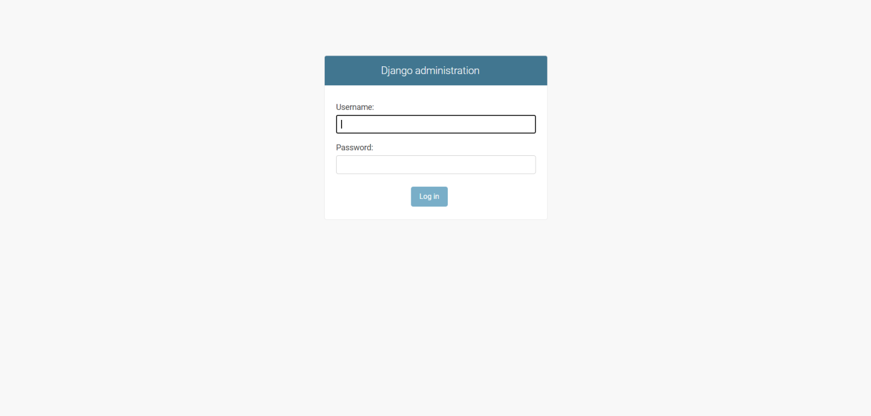

Step –2 Upload load data (New Items which needs to be added to inventory)

Press Add load

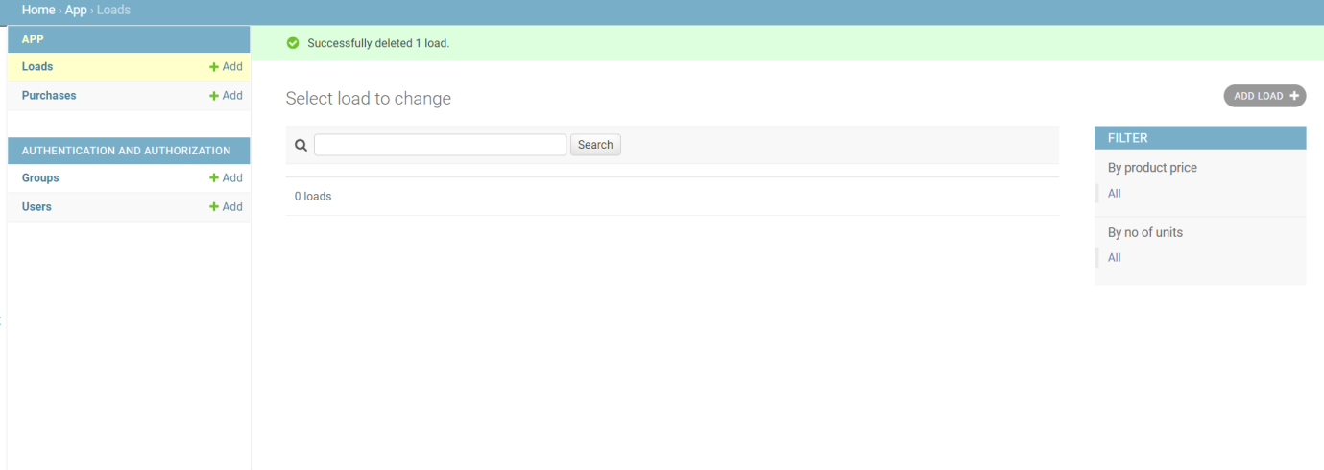Fill load details form

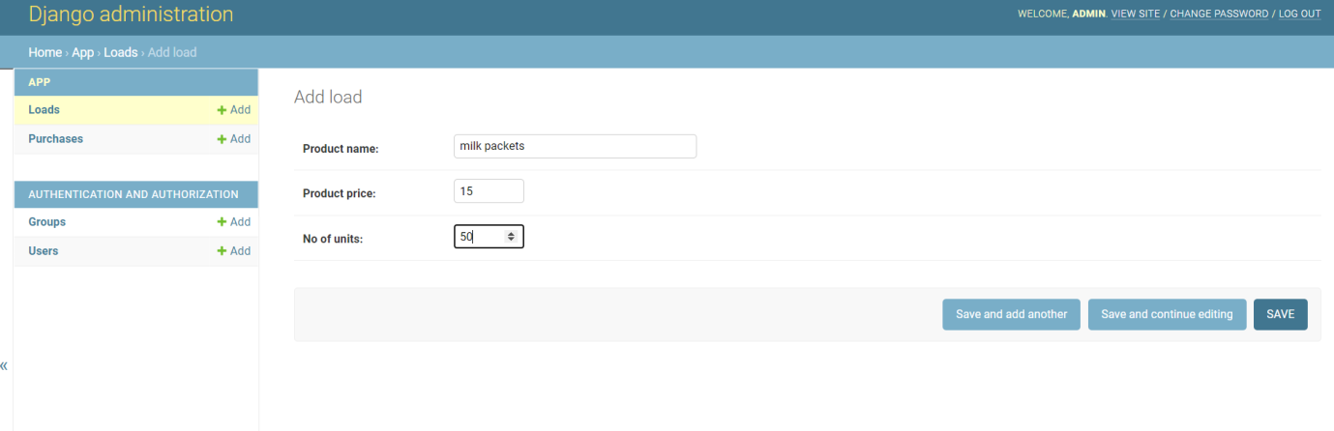

Load page showing the entry:-

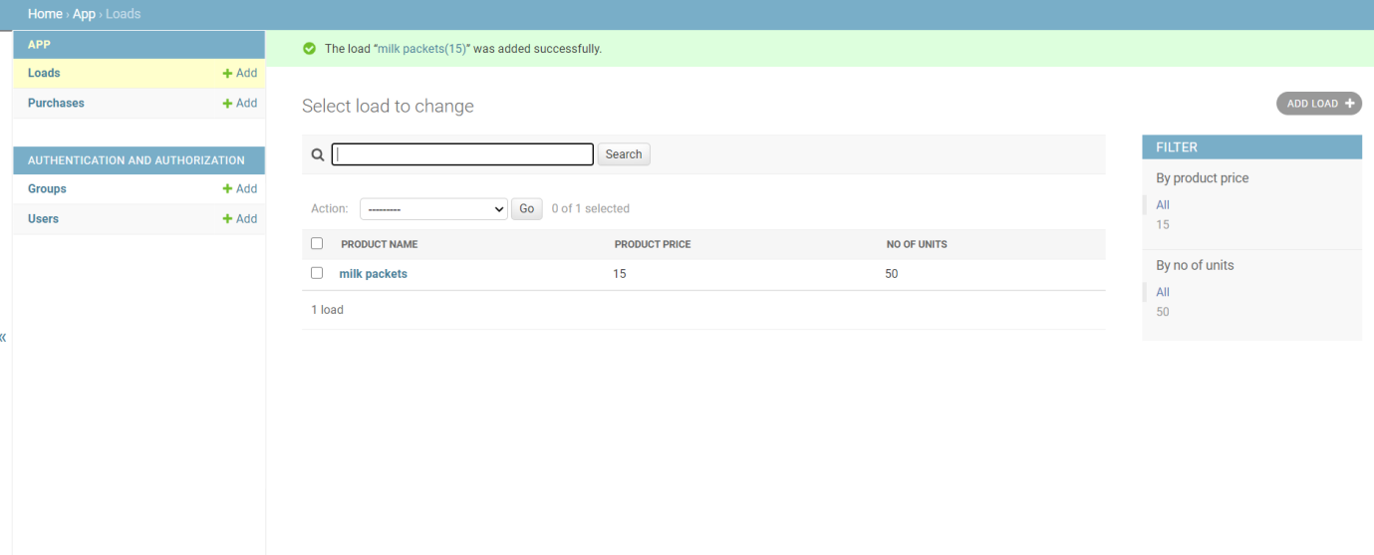

Fill Purchase form with user details:-

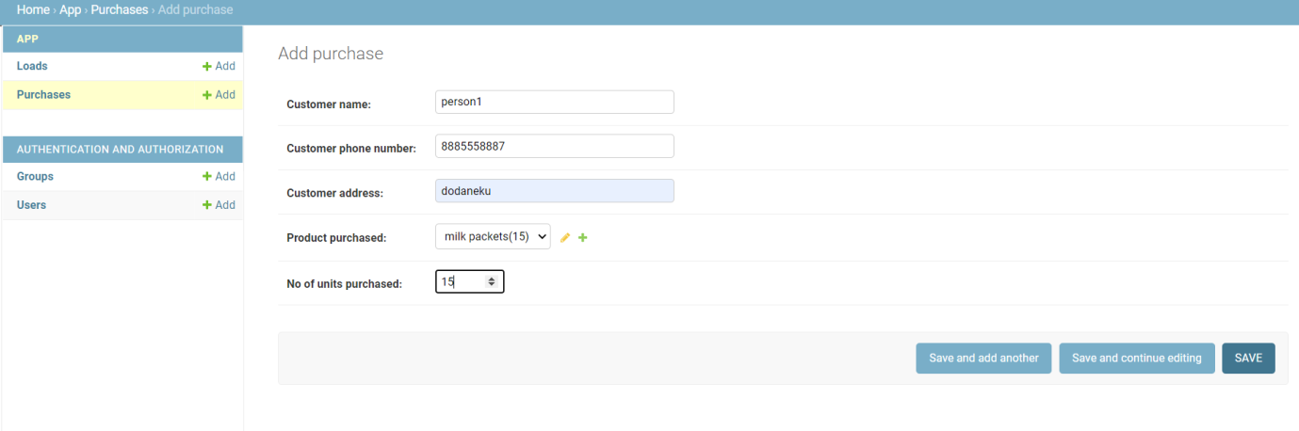

Every time a purchase is added , It will decrease same number of units in load.

**Source Code:-**

"""

Definition of models.

"""

fromdjango.dbimportmodels

fromdjango.db.models.signalsimportpost_save

fromdjango.dispatchimport receiver

# Create your models here.

classload(models.Model):

product_name=models.CharField(max_length=200)

product_price=models.IntegerField()

no_of_units=models.IntegerField()

def __str__(self):

returnself.product_name+"("+str(self.product_price)+")"

classpurchase(models.Model):

customer_name= models.CharField(max_length=200)

customer_phone_number= models.CharField(max_length=50)

customer_address= models.CharField(max_length=200)

product_purchased=models.ForeignKey(load,on_delete=models.CASCADE)

no_of_units_purchased=models.IntegerField()

def __str__(self):

returnself.customer_name

@receiver(post_save, sender=purchase )

defupdate_stock(sender, instance, **kwargs):

instance.product_purchased.no_of_units=instance.product_purchased.no_of_units-instance.no_of_units_purchased

instance.product_purchased.save()

fromdjango.contribimport admin

from .modelsimportload,purchase

import csv

fromdjango.httpimportHttpResponse

defexport_as_csv(self, request, queryset):

meta = self.model._meta

field_names = [field.name for field inmeta.fields]

response = HttpResponse(content_type='text/csv')

response['Content-Disposition'] = 'attachment; filename={}.csv'.format(meta)

writer = csv.writer(response)

writer.writerow(field_names)

forobjinqueryset:

row = writer.writerow([getattr(obj, field) for field infield_names])

return response

classloadadmin(admin.ModelAdmin):

actions=[export_as_csv]

list_display=('product_name','product_price','no_of_units')

search_fields=['product_name','product_price','no_of_units']

list_filter=['product_price','no_of_units']

admin.site.register(load, loadadmin)

classpurchaseadmin(admin.ModelAdmin):

actions=[export_as_csv]

search_fields=['customer_name','customer_phone_number','customer_address']

list_display=['customer_name','customer_phone_number','customer_address','product_purchased1','no_of_units_purchased']

def product_purchased1(self, obj):

returnobj.product_purchased.product_name

admin.site.register(purchase, purchaseadmin)

***Subchapter 1.1: BACKGROUND***

**Inventory Management System**

**It is** an  [software system](https://en.wikipedia.org/wiki/Software_system" \o "Software system) for tracking [inventory](https://en.wikipedia.org/wiki/Inventory) levels, orders, [sales](https://en.wikipedia.org/wiki/Sales) and deliveries.[[1]](https://en.wikipedia.org/wiki/Inventory_management_software#cite_note-1) It can also be used in the [manufacturing](https://en.wikipedia.org/wiki/Manufacturing) industry to create a [work order](https://en.wikipedia.org/wiki/Work_order), [bill of materials](https://en.wikipedia.org/wiki/Bill_of_materials) and other production-related documents. Companies use inventory management software to avoid product [overstock](https://en.wikipedia.org/wiki/Overstock) and outages. It is a tool for organizing inventory [data](https://en.wikipedia.org/wiki/Data) that before was generally stored in hard-copy form or in [spreadsheets](https://en.wikipedia.org/wiki/Spreadsheet).

## Features:

Inventory management software is made up of several key components working together to create a cohesive inventory of many organization's systems. These features include:

### Reorder point:

Should inventory reach a specific threshold, a company's inventory management system can be programmed to tell managers to reorder that product. This helps companies avoid running out of products or tying up too much capital in inventory.

### Asset tracking:

When a product is in a [warehouse](https://en.wikipedia.org/wiki/Warehouse) or store, it can be tracked via its [barcode](https://en.wikipedia.org/wiki/Barcode) and/or other tracking criteria, such as [serial number](https://en.wikipedia.org/wiki/Serial_number), lot number or revision number. Systems. for Business, Encyclopedia of Business, 2nd ed. Nowadays, inventory management software often utilizes [barcode](https://en.wikipedia.org/wiki/Barcode), [radio-frequency identification](https://en.wikipedia.org/wiki/Radio-frequency_identification) (RFID), and/or [wireless](https://en.wikipedia.org/wiki/Wireless) tracking technology.

### Service management:

Companies that are primarily service-oriented rather than product-oriented can use inventory management software to track the cost of the materials they use to provide services, such as cleaning supplies. This way, they can attach prices to their services that reflect the total [cost](https://en.wikipedia.org/wiki/Cost) of performing them.

### Product identification:

Barcodes are often the means whereby data on products and orders are inputted into inventory management software. A [barcode reader](https://en.wikipedia.org/wiki/Barcode_reader) is used to read barcodes and look up information on the products they represent. [Radio-frequency identification](https://en.wikipedia.org/wiki/Radio-frequency_identification) (RFID) tags and [wireless](https://en.wikipedia.org/wiki/Wireless) methods of product identification are also growing in popularity.

Modern inventory software programs may use QR codes or NFC tags to identify inventory items and smartphones as scanners.[[*citation needed*](https://en.wikipedia.org/wiki/Wikipedia:Citation_needed)] This method provides an option for businesses to track inventory using barcode scanning without a need to purchase expensive scanning hardware.

### Inventory optimization:

A fully automated demand forecasting and inventory optimization system to attain key inventory optimization metrics such as:

* Reorder point: the number of units that should trigger a replenishment order
* Order quantity: the number of units that should be reordered, based on the reorder point, stock on hand and stock on order.Lead demand: the number of units that will be sold during the lead time.
* Stock cover: the number of days left before a [stockout](https://en.wikipedia.org/wiki/Stockout" \o "Stockout) if no reorder is made.
* Accuracy: the expected accuracy of the forecasts

## Purpose:

Companies often use inventory management software to reduce their carrying costs.  The software is used to track products and parts as they are transported from a vendor to a warehouse, between warehouses, and finally to a retail location or directly to a customer.

**Inventory management software is used for a variety of purposes, including**:

* Maintaining a balance between too much and too little inventory.
* Tracking inventory as it is transported between locations.
* Receiving items into a warehouse or other location.
* Picking, packing and [shipping](https://en.wikipedia.org/wiki/Shipping) items from a warehouse.
* Keeping track of product sales and inventory levels.
* Cutting down on product [obsolescence](https://en.wikipedia.org/wiki/Obsolescence) and spoilage.
* Avoiding missing out on sales due to out-of-stock situations.

## Manufacturing uses:

Manufacturers primarily use inventory management software to create work orders and bills of materials. This facilitates the manufacturing process by helping manufacturers efficiently assemble the tools and parts they need to perform specific tasks. For more complex manufacturing jobs, manufacturers can create multilevel work orders and bills of materials, which have a timeline of processes that need to happen in the proper order to build a final product. Other work orders that can be created using inventory management software include reverse work orders and auto work orders. Manufacturers also use inventory management software for tracking assets, receiving new inventory and additional tasks businesses in other industries use it for.

## Advantages of  inventory management SYSTEM:

There are several advantages to using inventory management system in a business setting

.

### Cost savings:

A company's inventory represents one of its largest investments, along with its [workforce](https://en.wikipedia.org/wiki/Workforce) and locations. Inventory management software helps companies cut [expenses](https://en.wikipedia.org/wiki/Expense) by minimizing the amount of unnecessary parts and products in [storage](https://en.wikipedia.org/wiki/Warehouse). It also helps companies keep lost sales to a minimum by having enough stock on hand to meet demand.

### Increased efficiency:

Inventory management software often allows for automation of many inventory-related tasks. For example, software can automatically collect data, conduct [calculations](https://en.wikipedia.org/wiki/Calculations), and create records. This not only results in time savings, cost savings, but also increases business efficiency.

**Motivation:**

**=>Increase Efficiency:-**

Distribution of consumable products has been managed the same way for many years; however, market conditions are changing rapidly. Normally suppliers will send an account manager to their customer’s physical location to write replenishment stock orders. This dated way of restocking inventory is expensive, inefficient, and provides little accountability. Though many suppliers continue to make a significant investment in managing their customer’s inventory this way, recent studies show that many shops actually prefer alternative ways of having their supplies restocked.

**=>Maximize Profits:-**

From our inception in 2013, LeanTec’s mission has been simple: Develop tools for the collision repair industry that help suppliers and shops increase material profits. With a solid understanding of technology, software development, and a background in distribution to the collision repair industry, we have designed a full enterprise inventory management solution. We are confident that our solution, which provides benefits for the entire supply chain, will become the preferred method of managing consumable materials.

**References:-**

* Youtube
* Google
* wikpedia
* http://www.**inventorymanagement**.com